PROJECT STUDY REPORT

ON

College Management System

Using (JAVA, MySQL, HTML, CSS)

**Acknowledgement**

I would like to express my special thanks of gratitude to my mentor Miss Parul Joshi as well as Metacube software Pvt Ltd. who gave me the golden opportunity to do this wonderful project on College Management System which also helped me in doing a lot of Research and I came to know about so many new things I am really thankful to them.  
Secondly I would also like to thank my parents and friends who helped me a lot in finalizing this project within the limited time frame. Resource and feedback to carry out my internship program and hence complete this report.

I would also like to thank Metacube Informatics Limited for supporting me throughout my internship program. My endless thanks go to my mentor Miss Parul Joshi . They have provided their precious time and effort for completing my project and mentoring me throughout my time at Metacube. Their assistance for fulfilling my project especially in the authentication to domain was truly supportive.

My peers and colleagues at the college had also been very helpful, and they made my internship a more enjoyable and eventful one. I am very grateful to those people. Without them it was not possible to done the tasks successfully. I would like to thanks all the staffs of Metacube Informatics Limited to make my journey smooth.

**Executive Summary**

The Industrial Attachment program fulfils part of the requirements in pursuing the degree of Computer Science Engineering in the **Swami Keshvanand Institute of Management and Gramothan**. This report serves to summaries of the activities and experiences gained with **Metacube Software Pvt Ltd in** JAVA as an intern.

I found myself rather lucky by getting the chance to work in such an environment that Metacube Informatics Ltd provides. I got introduced to the most amazing experience was to work in a friendly work environment.

During the intern period, I gained valuable knowledge about real time software. I had to do various kinds of task like study, analysis and development. For technical knowledge, I had studied lots of technical issue such as programming concept, project development and database management.

As I joined in Development team, I had to learn specific procedures and steps to develop a complete software product. I was assigned in a project. Working with this project, I have achieved a lot of learning about new technologies.

Keeping the coding apart, there were also a few more challenges. Some of them were technical and some were non-technical. Coming almost at the end of my internship, I discovered that, some of my communicative and management skills have been improved to a great extent.

**ABSTRACT**

In this developing era of technology almost everything has gone on web.   
These days the college management system can be performed on any java-based platform. The main aim of this project is to provide all the information regarding student, faculty, and college.

Using this application, you can get any information about the college and about the students and faculty that are associated with the college.

College Management System is web-based application for technical evaluation. College Management System not only replace paperwork but also releases the workload of faculty. It fulfills the requirements of the institute. Students can access all their details without going to any physical destination. Even the teachers can access at the same time. Thus, the purpose of the site is to provide a system that saves the efforts and time of Faculty.

CONTENTS

**Acknowledgement** 2

**Executive Summary** 3

**Abstract** 4

Chapter 1. 6

* 1. Purpose. 6

1.2. Technologies used. 6

1.3. Hardware Interface. 6

1.4. Software Interface 6

1.5. Constraints. 6

Chapter 2: TOOLS 8-9

2.1 NetBeans 8

2.2 MySQL 9

Chapter 3: ER Diagram 10

Chapter 4: Login and Validation 11-15

Chapter 5: Screen Shots and explanation. 16-20

Chapter 6: Technical growth. 22

Chapter 7: Non-technical growth 23-25

College management System

1. **Purpose:** The purpose of College Management System is to allow the administrator of the organization to edit and find out the personal details of a student and allows the student to keep up to date his profile. It will also facilitate keeping all the records of students, such as their id, name, mailing address, phone number, DOB etc. So, all the information about a student will be available in a few seconds. Overall, it will make Student Information an easier job for the administrator and the student too.

2. **Technologies used:** This project is a web application that is developed on NetBeans and can be easily run on any java IDE. 1. NetBeans 2. MySQL.

3. **Hardware Interface:** Client Side: Internet Explorer: 6.0 Processor: Pentium IV 2.0 and above. RAM: 256 MB Online Examination Server Side: Processor: Pentium IV 2.0 and above. RAM: 1 GB Disk space: 4GB

4. **Software Interface**: Client Side: NetBeans, Web Browser, Windows Vista/7/10, Data Base Server: MySQL

5. **Constraints**: User interface is only in English i.e. no other language option is available. User can login only with his assigned username and password i.e. no guest facility is available. Limited to HTTP/HTTPS.

Feasibility Study

**What are the user’s demonstrable needs?**

User needs a web-based system, which will remove all the above-mentioned Problems that, the user is facing. The user wants a web-based system, which will reduce the bulk of paperwork, provide ease of work, flexibility, fast record finding, modifying, adding, removing and generating the reports.

**How can the problem be redefined?**

We proposed our perception of the system, in accordance with the problems of existing system by making a full layout of the system on paper. We tallied the problems and needs by existing system and requirements. We were further updating in the layout in the basis of redefined the problems. In feasibility study phase we had undergone through various steps, which are described as under: How feasible is the system proposed? This was analyzed by comparing the following factors with both the existing system and proposed system.

**Cost**

The cost required in the proposed system is comparatively less to the existing system. Effort Compared to the existing system the proposed system will provide a better working environment in which there will be ease of work and the effort required will be comparatively less.

**Time**

Also, the time required generating a report or for doing any other work will be comparatively very less than in the existing system. Record finding and updating will take less time than the existing system.

**Labor**

In the existing system the number of staffs required for completing the work is more while the new system will require quite a smaller number of staffs.

Tools

**2.2.1 NetBeans**

NetBeans IDE is a free, open source, integrated development environment (IDE) that enables you to develop desktop, mobile and web applications. The IDE supports application development in various languages, including Java, HTML5, PHP and C++. The IDE provides integrated support for the complete development cycle, from project creation through debugging, profiling and deployment. The IDE runs on Windows, Linux, Mac OS X, and other UNIX-based systems.

The IDE provides comprehensive support for JDK 7 technologies and the most recent Java enhancements. It is the first IDE that provides support for JDK 7, Java EE 7, and JavaFX 2. The IDE fully supports Java EE using the latest standards for Java, XML, Web services, and SQL and fully supports the Glassfish Server, the reference implementation of Java EE.



* + 1. **MySQL**

MySQL is a fast, easy-to-use RDBMS being used for many small and big businesses. MySQL is developed, marketed and supported by MySQL AB, which is a Swedish company. MySQL is becoming so popular because of many good reasons. MySQL is released under an open-source license. So you have nothing to pay to use it. MySQL is a very powerful program in its own right. It handles a large subset of the functionality of the most expensive and powerful database packages. MySQL uses a standard form of the well-known SQL data language.

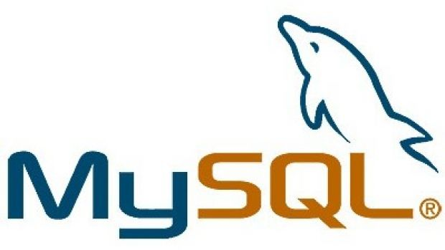

E-R Diagram

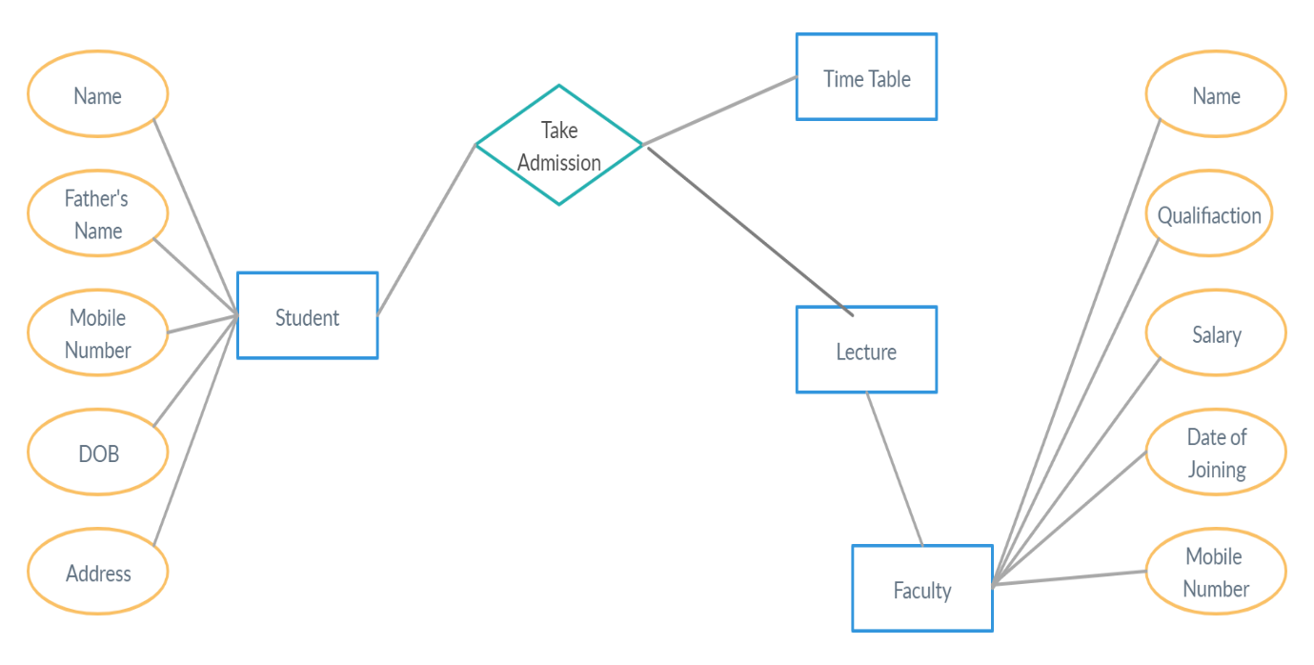

LOGIN AND VALIDATION

1 LOGIN USING USERNAME AND PASSWORD:

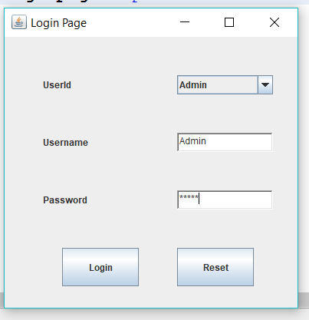

2: LOGIN CODE:

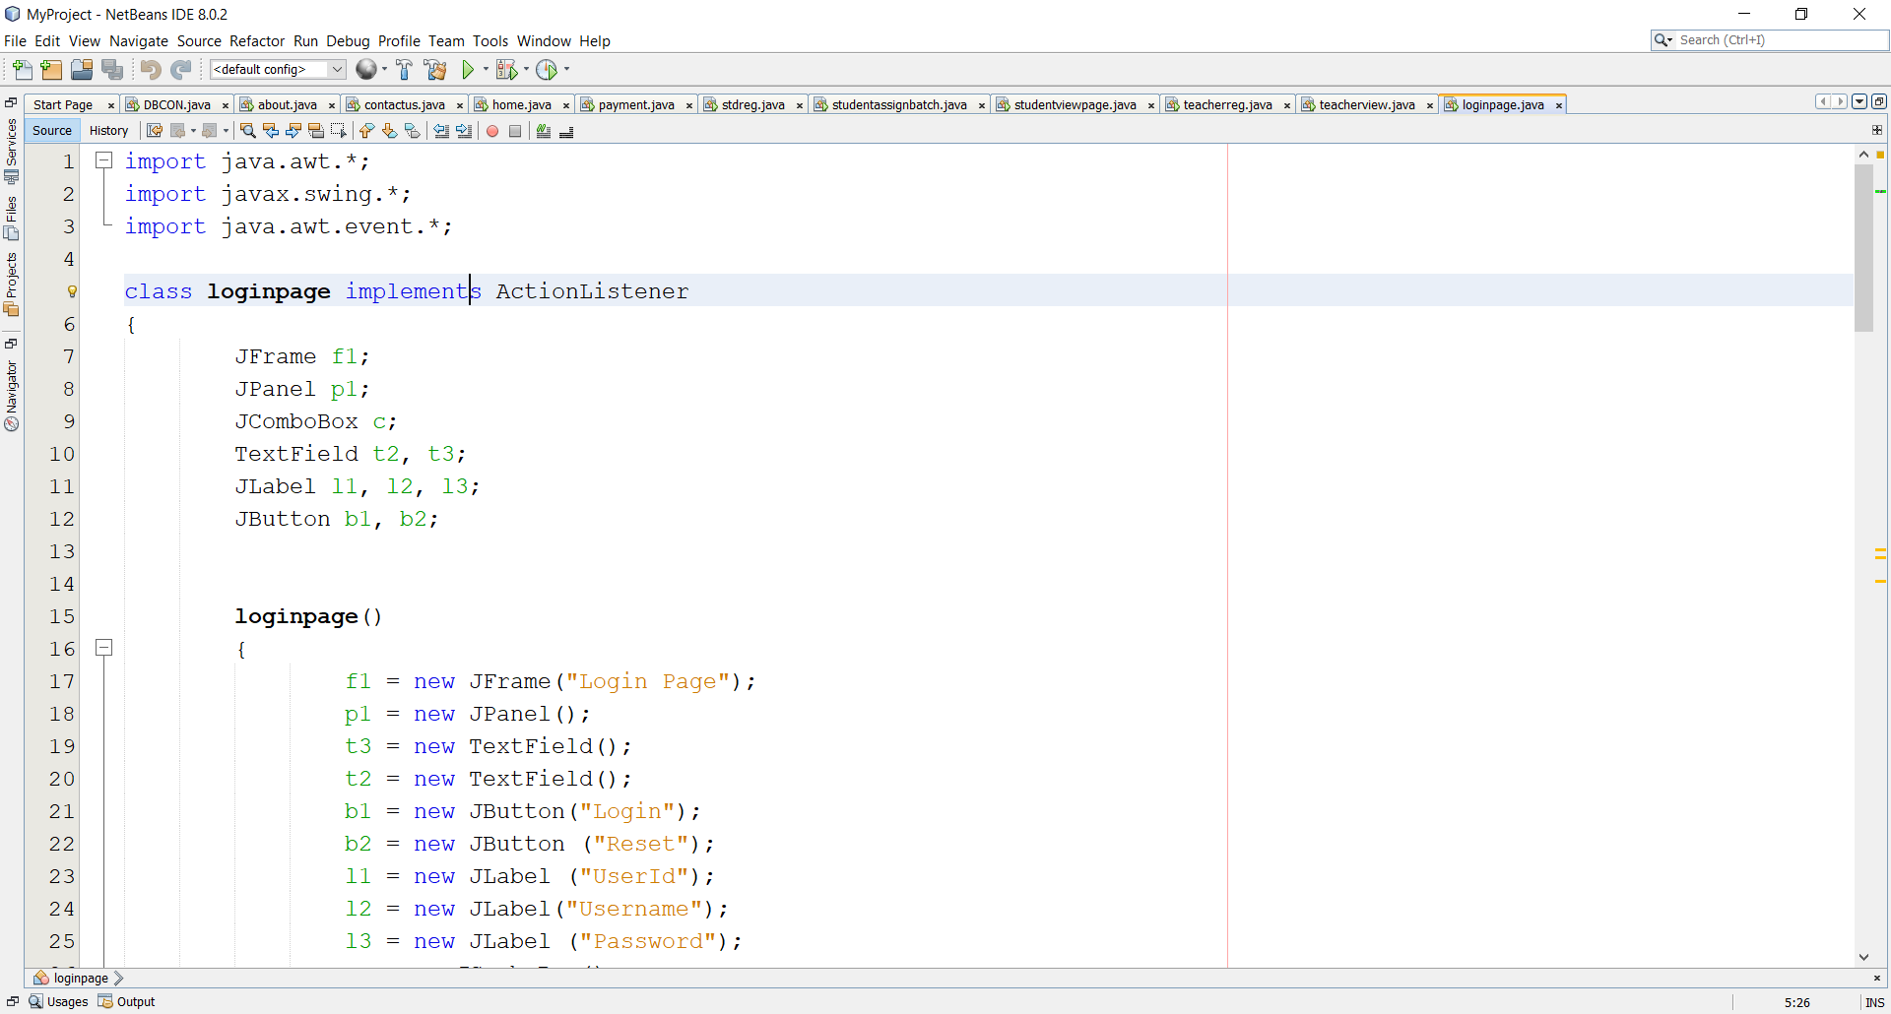

3. HOME PAGE:

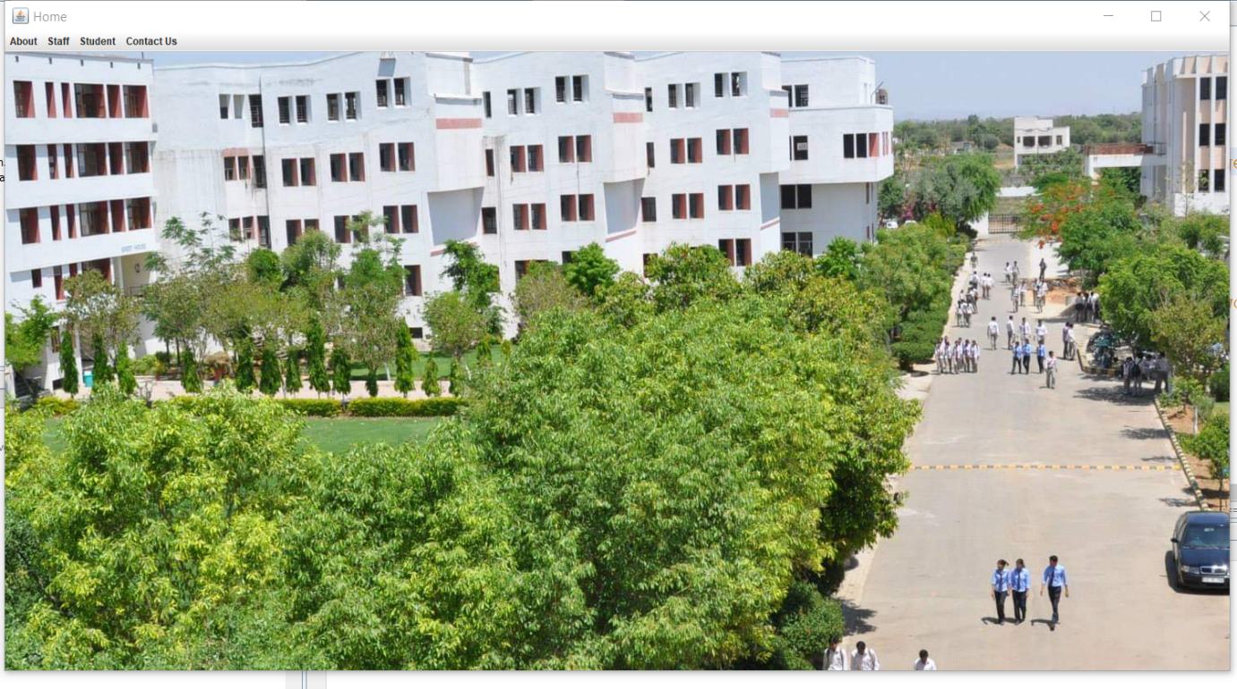

4.ABOUT THE COLLEGE:

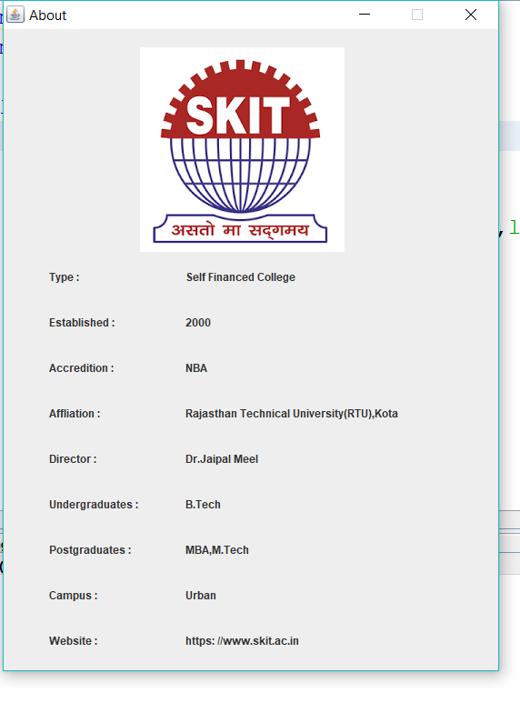

5. CONTACT US:

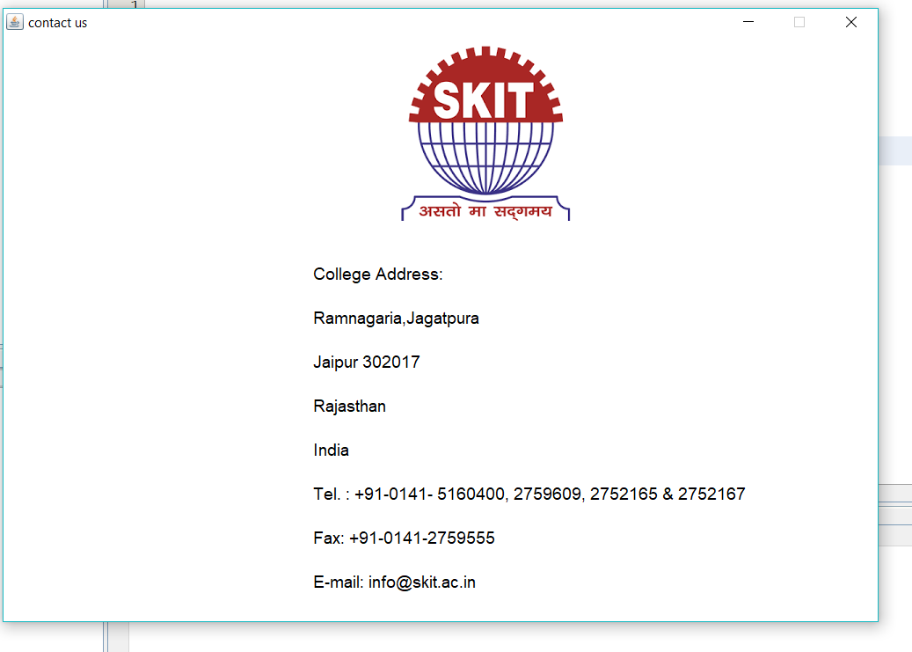

FRONTEND

STEP 1: Run the program and it redirect you to the Login Page.

STEP:2 Then after entering username and password.

STEP:3 You will see the below shown image as the login page.



STEP:4 Then after logging in you will be redirected to home page

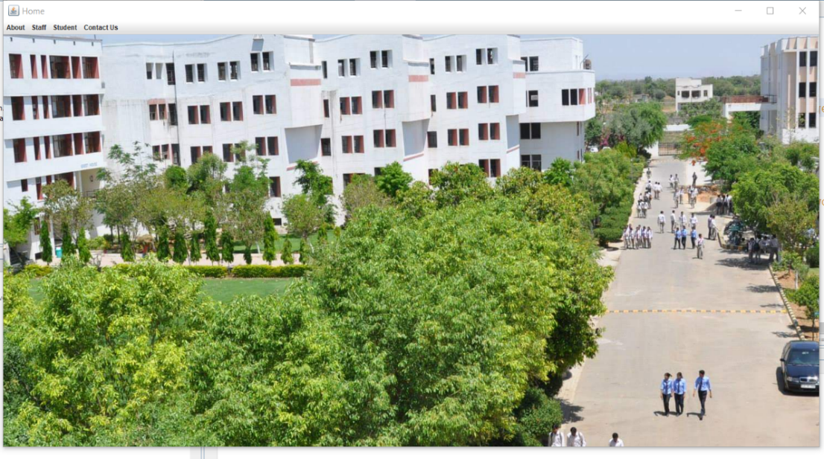

STEP:5 It will show Student Registration and Faculty Registration.

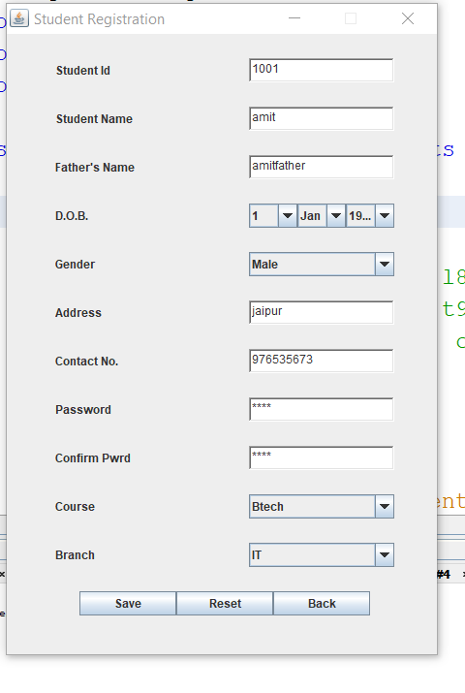

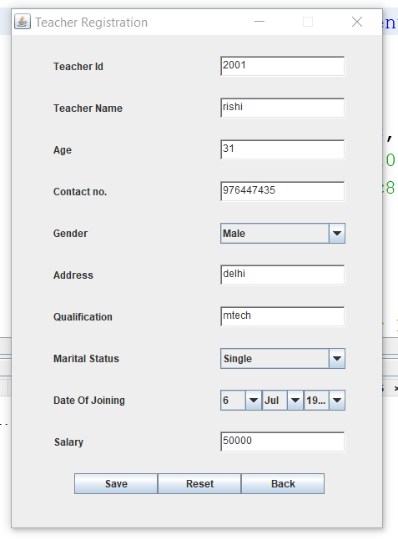

STEP:6 After that it will give you the option to modify the details of both students and faculty members.

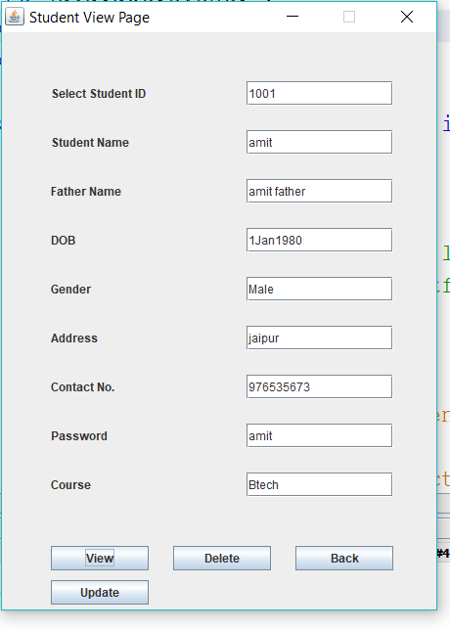

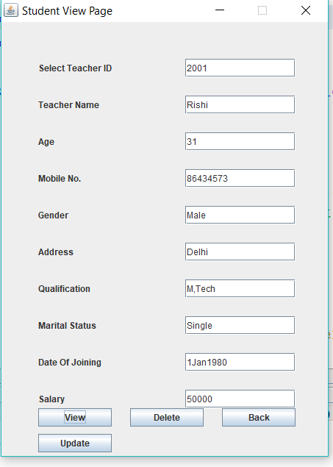

STEP:7 Then it will show the option to change the branch of the student and to modify the details.

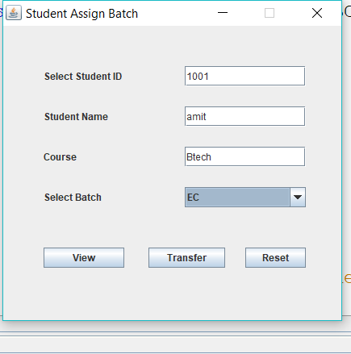

MySQL TABLES

STEP 1: IN MySQL we have one database with 2 tables.

Table 1: For Student

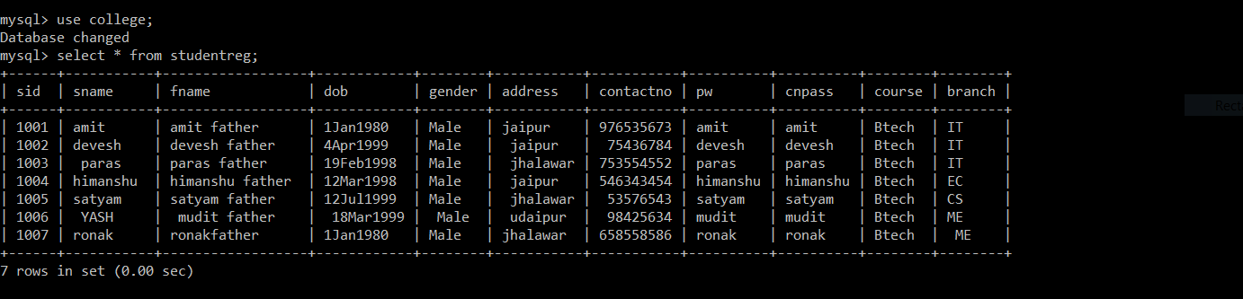

Table 2: For Faculty

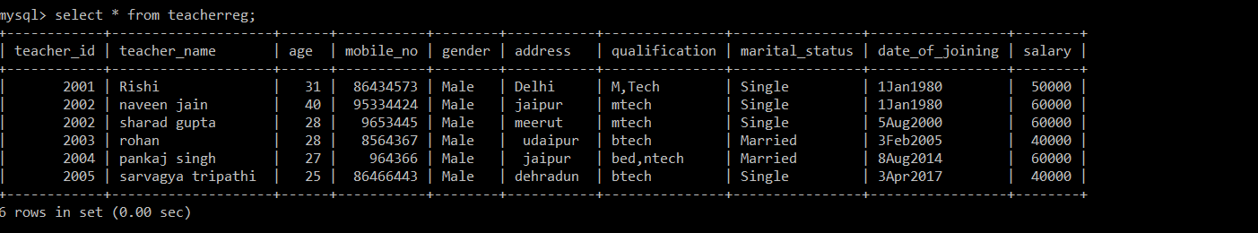

And then with details shown above you can login with specific username and password

**6. Technical Growth**

**6.1 Introduction**

An internship is the first opportunity to apply the skills and knowledge in real life field that I have learned from class room. Without the real-world experience, I am not capable to know how to translate theory into practice. Employers prefer candidates, who have experience, because it takes time to become accustomed to a professional role. It is crucial for me that I will use my internship experience to hone the career-related skills. In this section, I discuss about my improvement by leaning more professionalism from the professional people.

**6.2 Technical Skills**

This internship has provided me a wonderful opportunity to acquire various technological skills. Though it may take some more time to master those skills, at this moment I am confident to apply them in any of my projects. Google and YouTube helped me a lot to gain those skills. Some of the significant technical aspects that I have handled during the internship are listed below.

**6.3 Tools Involved**

Many tools were used to have the required work done as my project was based on asp.net therefore following tools were involved and as by doing work on them my technical growth was also being done.

* NetBeans
* MySQL
* Web services

**6.4 Conclusion**

I have gathered lots of experience and learning during my internship period. Involvement on real life projects taught me how to handle and cope with a very large project, how to manage everything easily, how to maintain project timeline and schedule, how to develop a complete project etc.

**7. Non-Technical Growth**

**7.1 Communicational skills**

If someone has a good communication skill, she/he will have a better chance to succeed. For the students, internships provide the best chance of improving their communication skills. I had my chance and I had tried my best to enhance my communication skills. The skills that I think have really improved are discussed here.

**7.2Presentation**

First one month of my internship, my supervisor suggested me to learn about some new technologies. Every day she asked what I learned and I presented my learning. In order to deliver a nice presentation, I had to practice more and more which eventually increased by presentation skill to a great extent.

**7.3 Information gathering**

Information gathering is a vital communication skill especially for a person who want to be a software engineer. The quality of our requirement engineering will heavily depend on how much information can we gather from a normal communication. As developing the web application, I had to improve my information gathering skills because if I had failed to understand the requirement properly, it would take much longer to complete the project.

**7.4 Listening**

Listening may sometime appear to sound boring but there is no alternative of becoming a good listener to understand the product. The meetings that I have undertaken during my internship were very much helpful in increasing my patience of listening to others. At the beginning of my internship, it was frequently occurred that when my supervisor talked to me something, before completing his speech I interfered there for presenting my speech. But now I think, through my internship I am capable for enhancing my listening power.

**7.5 Talking**

Sometimes I needed to talk about my work. When I faced a problem, I went to my mentor to talk about this problem. Firstly, I was silent during my mentor meeting. But my mentor always inspired me to talk about the discussion topic. Day by day, I tried to discuss in the meeting and talked more with them. If I did not understand something, I continuously questioned them until my confusion was not clear. It also improved my communication skills.

**7.6 Management skills**

Management is another skill that I gained from my internship. I was lucky because I got the chance of managing something during my internship. There was always a scope of managing myself to increase my management capabilities.

I have to plan for doing any task. Before doing any task, I have planned how to do it. Sometimes, I do more than one task at a specific time. In that moment, I have planned and managed my schedule to complete all of those tasks.

**7.7 Problem solving skills**

From my internship I also learnt how to solve problem easily. My analytical and critical thinking help me to solve problem which I faced. For solving problem, I follow the basic steps of problem solving process. These steps are:

1. Identify ad define the problem
2. Analyse the problem
3. Identify possible solutions
4. Select ad plan the solution
5. Implement the solution
6. Evaluate the solution

The following figure illustrates the problem-solving process:

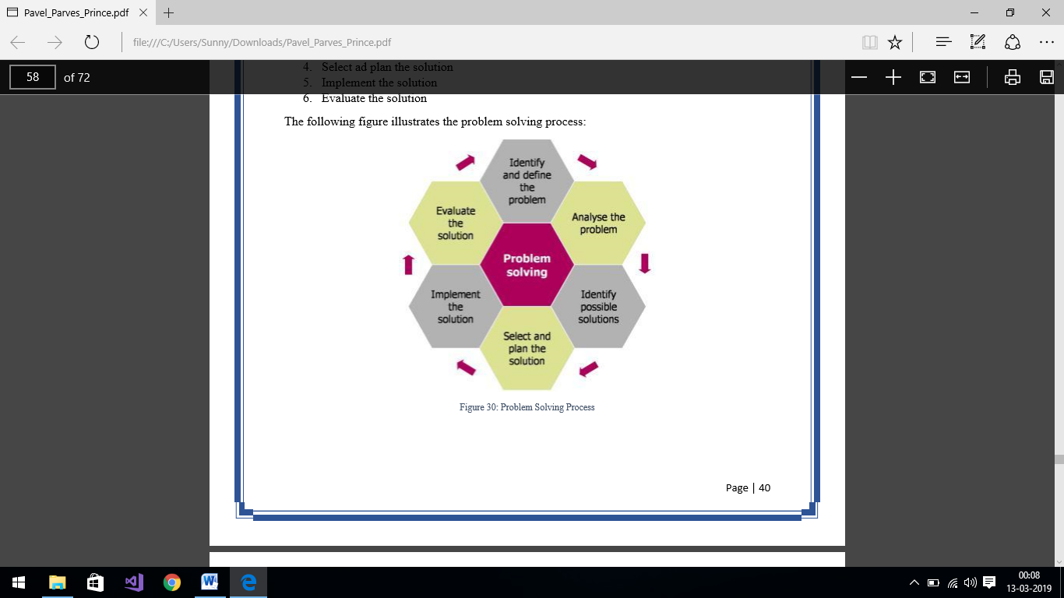

**7.8 Conclusion**

This whole journey also taught me to be passionate, hard-working, rational, dependable, punctual, intelligent, cordial, enthusiastic, arduous and confident. So, I think that my overall progress during my internship period was noteworthy and praiseworthy and it will play a key role throughout my whole life.